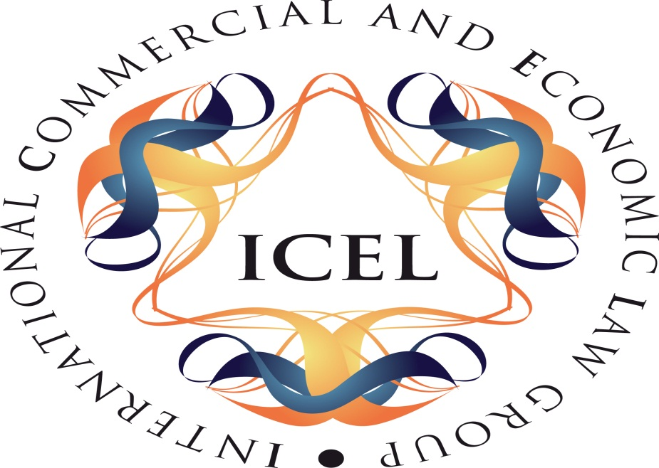

Compensation Culture or Accident Culture?
Comparative Tort Law Reform in the 21st Century
Call for Papers

June 2014 will mark the 10th anniversary of the coming into operation of the Personal Injuries Assessment Board in Ireland; the Board quantifies damages in most classes of personal injury case where liability is not in dispute. 2014 is also the 10th anniversary of the enactment of the Civil Liability and Courts Act 2004, which introduced a variety of procedural reforms to the tort process. These reforms were introduced to deal with a variety of perceived problems in the tort system.

To mark the anniversary, the International Commercial and Economic Law Research Group at the School of Law, University of Limerick is hosting a conference on comparative compensation culture and tort reform at the end of May 2014 (provisionally on 23 and 24 May). It will seek to bring together a variety of perspectives from academics and practitioners in law, insurance and the administration of compensation schemes. In particular, it seeks to focus on the position in Ireland, England & Wales and Australia, though other jurisdictions may be included if there is sufficient interest expressed.

Anyone interested in offering a paper on any aspect of this theme should submit an outline to eoin.quill@ul.ie by Friday 4 October 2013.

Eoin Quill
Director ICELRG
School of Law
University of Limerick
Ireland.

